Matheus Ferreira
BSEE USF Student

Retro Gaming System Project Documentation
In this project I worked alongside Zachary Winningham to implement python-based retro games onto a handheld console. Each of us is developing our own game, but we are sharing the hardware. We chose to use a hardware kit called Retroflag GPi CASE 2W alongside the Raspberry Pi Zero 2W. We are using the pygame python package to assist in the game development process.
Zachary and I initially met up to plan which hardware we would use and to schedule a timeline for when we would work on finalizing our games and our hardware implementation, as well as adding Bluetooth features and getting a unified UI to work.

Developing my game: Little_Dude
I find the pseudo code is great for establishing a baseline for what a group’s goal is in developing a large software project, where each team member works on a given part of the software. However, with an independent project, I have a good idea of what I want to develop, and I might instead write notes on ideas for any problem I might encounter. Luckily pygame makes game development a bit of a no brainer, so I didn’t even have to write down extensive notes. I just made sure to comment on my source code well and occasionally needed some scratch paper to help out visualizing certain elements on the screen. So, I hit the ground running right away and just started developing my game.
To assist in version control and being able to access my code through a repository, I used GitHub desktop to begin development. Additionally, I used VSCode, with AI inline suggestions, and frequently used Gemini to help me with figuring out various functions within pygame.

Setting up on PC
- Little_Dude game local copy files
https://github.com/mrferreira-net/Little_Dude
source-pc.py
/Data/
launch.bat

- Download the .zip file on the Little_Dude github page.
- Extract the .zip file.
- Double click the install.bat file and run the install process.
- Double click the launch.bat file to launch the game.

Setting up on handheld

Hardware Requirements
- GPI CASE 2W
- Raspberry Pi Zero 2W
- microSD card

Software Requirements:
- PuTTY for SSH communication with device
https://www.chiark.greenend.org.uk/~sgtatham/putty/latest.html
- Little_Dude game local copy files
https://github.com/mrferreira-net/Little_Dude
source.py
/Data/
launch.sh
- Raspberry PI imager
https://downloads.raspberrypi.org/imager/imager_latest.exe
- Display patch
https://github.com/RetroFlag/GPICASE2W-display-patch
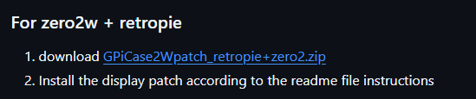

- Terminal command for safe shutdown
Save this command to be used later in the setup process
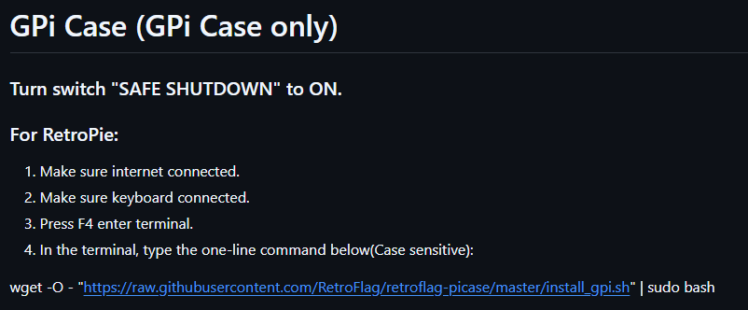
wget -O - "https://raw.githubusercontent.com/RetroFlag/retroflag-picase/master/install_gpi.sh" | sudo bash
- wpa_supplicant.conf
Can be made by saving .txt file as .conf:
country=US
ctrl_interface=DIR=/var/run/wpa_supplicant GROUP=netdev
update_config=1

# RETROPIE CONFIG START
network={
ssid=""
psk=""
}
# RETROPIE CONFIG END

